Name: Mai Duc An

Student ID: 20210008

**IPayment Interface**

1. Interface description

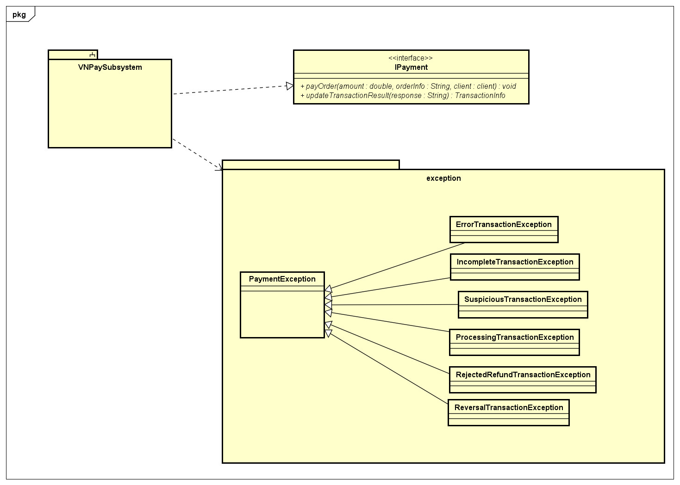

* The Payment interface serves as a communication channel between various system components and the VNPay subsystem, facilitating user payments for orders. It specifies two key functions for interacting with the subsystem: sending payment order messages and updating transaction details.

1. Operation definition

+ payOrder(amount : double, orderInfo : String, client : client) : void: This method initiates a payment process for a specified amount of money, providing orderInfo about the transaction and the client information. It does not return any value (void). This operation creates request to process a payment of the order

+ updateTransactionResult(response : String) : TransactionInfo: This function updates transaction information based on the response received from the payment process. It returns a TransactionInfo object containing updated details about the transaction. This operation displays the result of the payment